**WEEK 3 HANDSON :**

**Exercise 4: Creating and Configuring a Maven Project**

**Scenario:**

**You need to set up a new Maven project for the library management application and add Spring dependencies.**

**Steps:**

1. **Create a New Maven Project:**
   * **Create a new Maven project named LibraryManagement.**
2. **Add Spring Dependencies in pom.xml:**
   * **Include dependencies for Spring Context, Spring AOP, and Spring WebMVC.**
3. **Configure Maven Plugins:**
   * **Configure the Maven Compiler Plugin for Java version 1.8 in the pom.xml file.**

**CODE AND OUTPUTS :**

**STEP1 : Create a New Maven Project:**

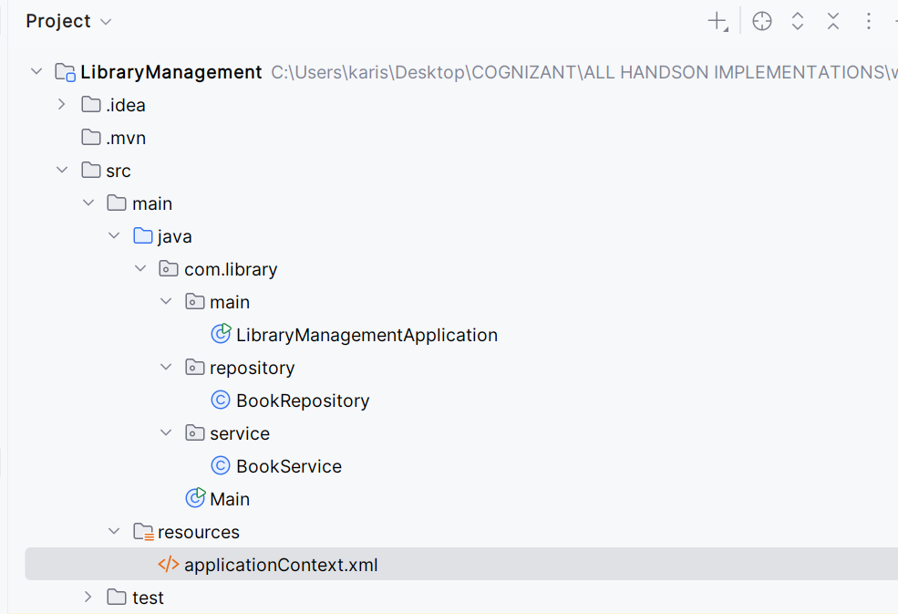

**STEP2 : Add Spring Dependencies in pom.xml:**

**<dependencies>  
  
 *<!-- Spring Context -->* <dependency>  
 <groupId>org.springframework</groupId>  
 <artifactId>spring-context</artifactId>  
 <version>5.3.32</version>  
 </dependency>  
  
 *<!-- Spring AOP -->* <dependency>  
 <groupId>org.springframework</groupId>  
 <artifactId>spring-aop</artifactId>  
 <version>5.3.32</version>  
 </dependency>  
  
 *<!-- Spring Web MVC -->* <dependency>  
 <groupId>org.springframework</groupId>  
 <artifactId>spring-webmvc</artifactId>  
 <version>5.3.32</version>  
 </dependency>  
  
 *<!-- (Optional) Servlet API if planning to build a web app -->* <dependency>  
 <groupId>javax.servlet</groupId>  
 <artifactId>javax.servlet-api</artifactId>  
 <version>4.0.1</version>  
 <scope>provided</scope>  
 </dependency>  
 </dependencies>**

**Step 3 : Configure Maven Plugins:**

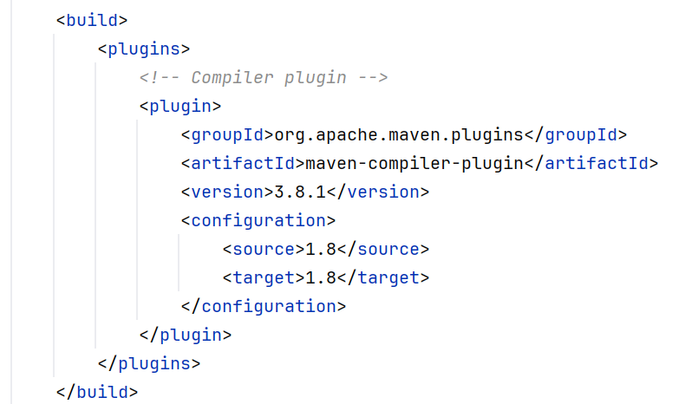

**Done all tasks Successfully !!!!!**